

**The Asian Journal of Professional and Business Studies**

Please cite this article as: Author1*, & Author2. (2025). [Insert your 12-word title here.]. *The Asian Journal of Professional and Business Studies*, *6*(2), pp, DOI

TITLE IS SUGGESTED FOR A MAXIMUM LENGTH OF 12 WORDS

Author1*, Author2

*Corresponding author: [author@email.com](mailto:author@email.com)

1,2Faculty/Department, Affiliation

DOI:

Received xx April 2024, Accepted xx June 2024, Available online xx May 2023

**ABSTRACT**

This document represents the required format for manuscript preparation for publication. By having a standardized format of submission, the editor and reviewers can make the assessment process with clarity. This template is to assist the author in familiarizing with the submission format and understanding the function of each section. On writing the actual abstract, it should be between 200 - 250 words in a single paragraph. It should be a concise summary that clearly outlines the paper’s rationale, methodology, findings, and contribution. The body text should be presented with justified alignment.

Keywords: *Keywords1, Keywords2, Keywords3, Keywords4, Keywords5*

1. INTRODUCTION

HEADING 1 (Align left, UPPERCASE. Bold, Times New Roman 12)

This template is constructed to assist authors in presenting their work so that it will be easy to be reviewed by the reviewers. Having a standard template will also assist in the eventual publication process should the paper is accepted. Submitting an article that is easier to be read by the reviewer will assist in expediting the review process.

This template was designed such that the author can substitute each section with one’s work accordingly and expand it as necessary. It includes samples of referencing and type formatting which is expected when submitting a manuscript in MS Word, which is the only acceptable format. The manuscript must not exceed 10,000 words excluding references and appendices. The manuscript also should meet the similarity index for less than 30%. The body text should be presented in a single paragraph with justified alignment.

1. LITERATURE REVIEW
   1. **Dependent Variable**

**Heading 2 (Align left, Cap First Word, Bold, Times New Roman 12)**

Submitted an article should be structured in a way that follows a suitable journal publication style. The paper should be segmented with appropriate headings such as the following flow: Abstract, Introduction, Methodology, Results, Discussion/Conclusion, and References. However, the author may include other headings as deem necessary, such as Literature Review and Acknowledgement. The body text should be presented in a single paragraph with justified alignment.

* 1. **Independent Variable 1** 
     1. ***Subheading (Heading 3) (Align left, Italic, Cap First Word, Times New Roman 12)***

Sub-heading may be inserted to improve the structure of the paper. This paragraph is an example of how a sub-heading. If required, a further hierarchical breakdown can utilise the subsection or bullet points. The body text should be presented in a single paragraph with justified alignment.

* + - 1. **Subsections (Align Left, Sentence Case, Times New Roman 11)**

This section is to illustrate format in the subsection. The text should be represented in single column with justified alignment. The body text should be presented with justified alignment.

1. METHODOLOGY

FIGURES AND TABLES

Figures and tables are to be embedded in the main text body. They should not have cosmetic enhancement such as a shadow frame. One blank line separates the figure or table with the following text.

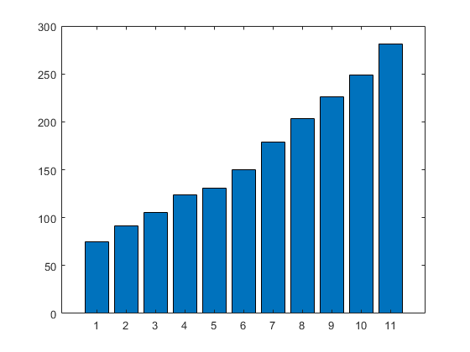

Figure 1. Each figure must be explained by a legend at the bottom using the same format as body text

Table 1. Each table must be preceded with a label placed with sequence number and title using the same format as body text.

|  |  |  |  |  |  |
| --- | --- | --- | --- | --- | --- |
| **TYPE** | **CASE** | **FONT** | **SIZE** | **FORMAT** | **ALIGNMENT** |
| HEADING | UPPER | TIMES NEW ROMAN | 12 | BOLD | CENTER |
| SUBHEADING | UPPER | TIMES NEW ROMAN | 12 | NORMAL | CENTRE |
| Subsection | Sentence | TIMES NEW ROMAN | 12 | NORMAL | CENTRE |

1. FINDINGS AND DISCUSSION

[Write here – Justify Align, Times New Roman 10, single spacing]

1. CONCLUSION

[Write here – Justify Align, Times New Roman 10, single spacing]

1. ACKNOWLEDGEMENT

The authors would like to express their sincere gratitude to [**Name of Institution or Organization**] for providing the resources and support necessary to complete this study. We would also like to thank all participants who contributed their time and insights to this research. Special appreciation is extended to colleagues and peers who offered valuable feedback during the development of this manuscript.

If applicable, this research was supported by [**Funding Agency/Grant Number, if any**].

1. CONFLICT OF INTEREST

The authors declare that they have no known competing financial interests or personal relationships that could have appeared to influence the work reported in the paper.

1. AUTHOR CONTRIBUTION STATEMENT

*Author’s name 1- contribution*

*Author’s name 2- contribution*

*Author’s name 3- contribution*

*Author’s name 4- contribution*

Example

Author 1 contributed to the conceptualization, research design, and writing of the original draft.

Author 2 was responsible for data collection, analysis, and validation of the results.

Author 3 provided supervision, critical review, and editing of the final manuscript.

All authors have read and approved the final version of the manuscript.

1. ETHICS STATEMENT

This research was conducted in accordance with the ethical standards of [**Name of Institution**] and adhered to the principles outlined in the Declaration of Helsinki. Ethical approval was obtained from the [**Institutional Ethics Committee/Review Board**] under reference number [**Approval Number, if applicable**]. All participants were informed about the purpose of the study and provided written informed consent prior to participation. Participants’ privacy and confidentiality were strictly maintained, and data collected were used solely for academic purposes.

REFERENCES

APA 7th edition

American Psychological Association. (2010). *Mastering APA style: Student's workbook and training guide* (6th ed.). Washington, DC: American Psychological Association. DOI

Edwards, A. A., Steacy, L. M., Siegelman, N., Rigobon, V. M., Kearns, D. M., Rueckl, J. G., & Compton,D. L. (2022). Unpacking the unique relationship between set for variability and word reading development: Examining word- and child-level predictors of performance. *Journal of Educational Psychology*, *114*(6), 1242–1256. <https://doi.org/10.1037/edu0000696>

Levenson, H., Jinich, S., Vaz, A., & Rousmaniere, T. (2025). *Deliberate practice in emotionally focused couple therapy*. American Psychological Association. <https://doi.org/10.1037/0000436-000>

Zeleke, W. A., Hughes, T. L., & Drozda, N. (2020). Home–school collaboration to promote mind–body health. In C. Maykel & M. A. Bray (Eds.), *Promoting mind–body health in schools: Interventions for mental health professionals* (pp. 11–26). American Psychological Association. <https://doi.org/10.1037/0000157-002>