INTERNATIONAL JOURNAL OF SOCIO-ECONOMIC
PLANNING
IJSEP
e-ISSN: 3030-6299

https://journal.uptm.edu.my/index.php/ijsep/index

Title is Suggested for a Maximum Length of 12 Words, Using Cambria 18
Author ¹*, Author²
^{1, 2} Faculty of Business and Accounting, University Poly-Tech Malaysia
*Corresponding Email: author@uptm.edu.my
DOI: leave blank

Article Info | Abstract
Received: 1 August 2025  Accepted: 1 December 2025  Available online: 30 December 2025 | This document represents the required format for manuscript preparation for publication. By having a standardized format of submission, the editor and reviewers can make the assessment process with clarity. This template is to assist the author in familiarising themselves with the submission format and understanding the function of each section. On writing the actual abstract, it should be between 200 - 250 words in a single paragraph. It should be a concise summary that clearly outlines the paper’s rationale, methodology, findings, and contribution. The body text should be presented with justified alignment.
Keywords
Keywords1, Keywords2, Keywords3, Keywords4, Keywords

Introduction (Heading 1 - Align left, Capitalize Each Word. Bold, Calambria 12)

This template is constructed to assist authors in presenting their work so that it will be easy to be reviewed by the reviewers. Having a standard template will also assist in the eventual publication process should the paper is accepted. Submitting an article that is easier to be read by the reviewer will assist in expediting the review process. This template was designed such that the author can substitute each section with one’s work accordingly and expand it as necessary. It includes samples of referencing and type formatting which is expected when submitting a manuscript in MS Word, which is the only acceptable format. The manuscript must not exceed 10,000 words excluding references and appendices. The manuscript also should meet the similarity index for less than 30%. The body text should be presented in a single paragraph with justified alignment.

2.0 Literature Review

2.1 Main Variable (Heading 2 - Align left, Cap First Word, Bold, Times New Roman 12)

Submitted an article should be structured in a way that follows a suitable journal publication style. The paper should be segmented with appropriate headings such as the following flow: Abstract, Introduction, Methodology, Results, Discussion/Conclusion, and References. However, the author may include other headings as deem necessary, such as Literature Review and Acknowledgement. The body text should be presented in a single paragraph with justified alignment

2.2 Secondary Variable
2.2.1 Subheading (Heading 3) (Align left, Cap First Word, Times New Roman 12)

The subheading may be inserted to improve the structure of the paper. This paragraph is an example of a sub-heading. If required, a further hierarchical breakdown can utilise the subsection or bullet points. The body text should be presented in a single paragraph with justified alignment.

2.2.1.1. Subsections (Align Left, Italic, Sentence Case, Times New Roman 11)

This section is to illustrate format in the subsection. The text should be represented in single column with justified alignment. The body text should be presented with justified alignment.
3. Methodology
3.1 Research Design
The figures and tables are to be embedded in the main text body. They should not have cosmetic enhancements such as a shadow frame. One blank line separates the figure or table from the following text.
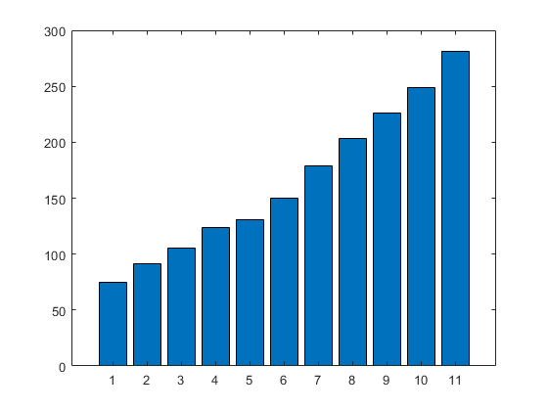
Figure 1. Each figure must be explained by a legend at the bottom using the same format as body text

3.2 Sampling Design
Table 1. Each table must be preceded by a label placed with a sequence number and title using the same format as body text.
TYPE | CASE | FONT | SIZE | FORMAT | ALIGNMENT
HEADING | UPPER | TIMES NEW ROMAN | 12 | BOLD | CENTER
SUBHEADING | UPPER | TIMES NEW ROMAN | 12 | NORMAL | CENTRE
Subsection | Sentence | TIMES NEW ROMAN | 12 | NORMAL | CENTRE

4. Findings and Discussion [Write here – Justify Align, Times New Roman 10, single spacing]
[Write here – Justify Align, Calibria 11, single spacing]

5. Conclusion
[Write here – Justify Align, Calibri 11, single spacing]

- Acknowledgement
The authors would like to express their sincere gratitude to [Name of Institution or Organization] for providing the resources and support necessary to complete this study. We would also like to thank all participants who contributed their time and insights to this research. Special appreciation is extended to colleagues and peers who offered valuable feedback during the development of this manuscript.
If applicable, this research was supported by [Funding Agency/Grant Number, if any].

- Conflict Of Interest
The authors declare that they have no known competing financial interests or personal relationships that could have appeared to influence the work reported in the paper.

- Author Contribution Statement
Author’s name 1- contribution
Author’s name 2- contribution
Author’s name 3- contribution
Author’s name 4- contribution
Example
Author 1 contributed to the conceptualization, research design, and writing of the original draft.
Author 2 was responsible for data collection, analysis, and validation of the results.
Author 3 provided supervision, critical review, and editing of the final manuscript.
All authors have read and approved the final version of the manuscript.

- Ethics Statement
This research was conducted in accordance with the ethical standards of [Name of Institution] and adhered to the principles outlined in the Declaration of Helsinki. Ethical approval was obtained from the [Institutional Ethics Committee/Review Board] under reference number [Approval Number, if applicable]. All participants were informed about the purpose of the study and provided written informed consent prior to participation. Participants’ privacy and confidentiality were strictly maintained, and data collected were used solely for academic purposes.

References (using APA 7)
Alarabiat, A., & Wahbeh, N. (2021). Unearthing citizens' acceptance factors for e‐participation initiatives through Facebook. The Electronic Journal of Information Systems in Developing Countries, 87(6), e12194.
Alblooshi, M. I. M. I., & Kassim, E. S. (2021). Exploring citizens’ perception of Abu Dhabi Policing e- Service quality. International Journal of Academic Research in Business & Social Sciences, 11(10). https://doi.org/10.6007/ijarbss/v11-i10/11115

